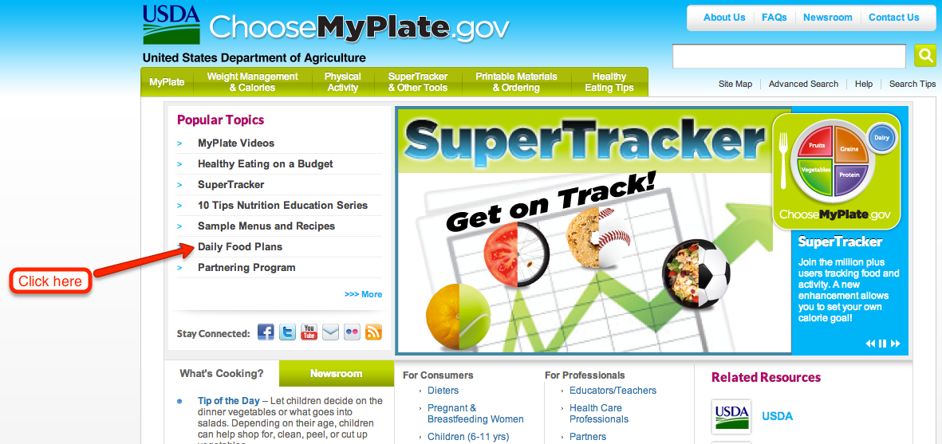

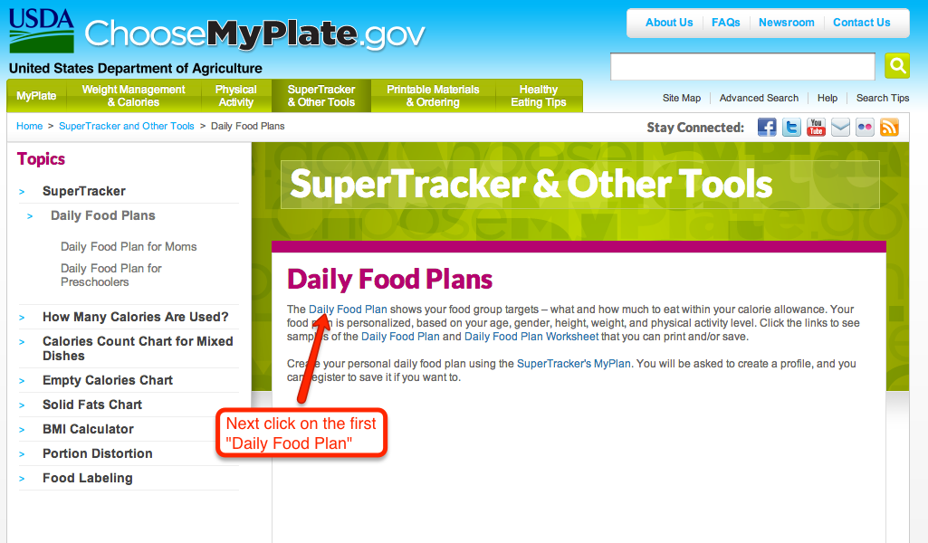

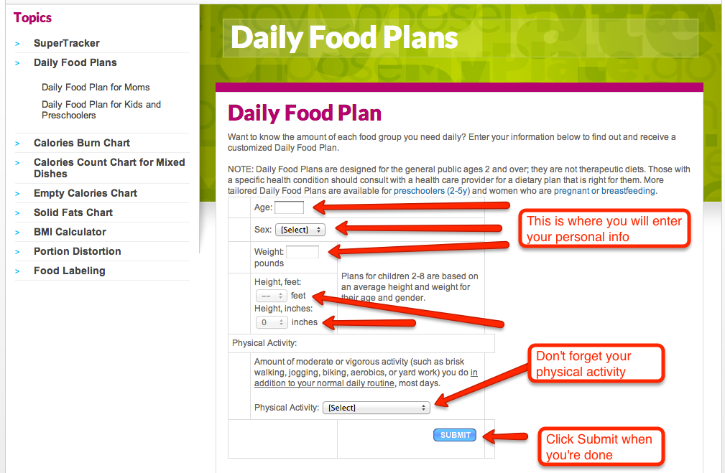

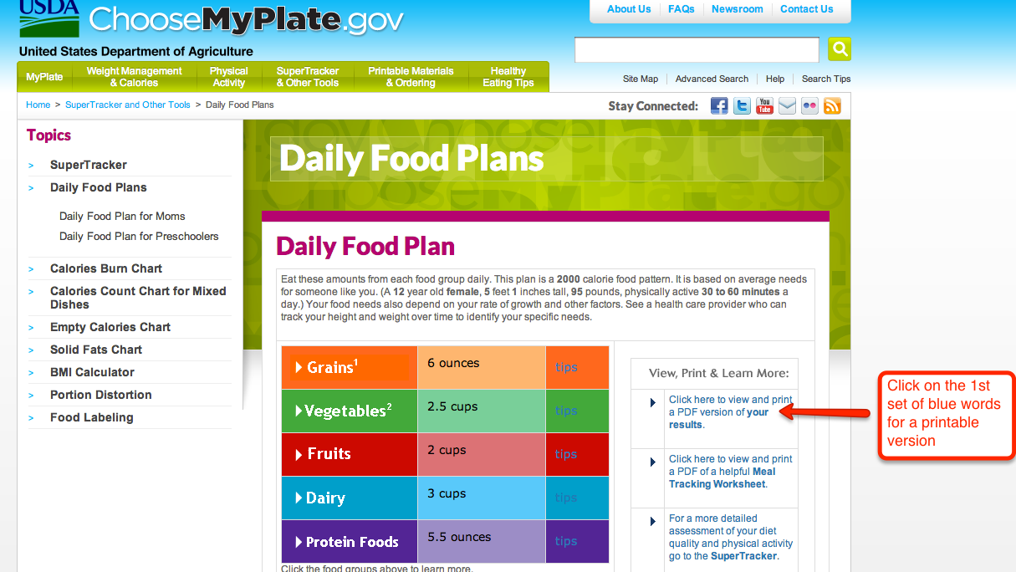
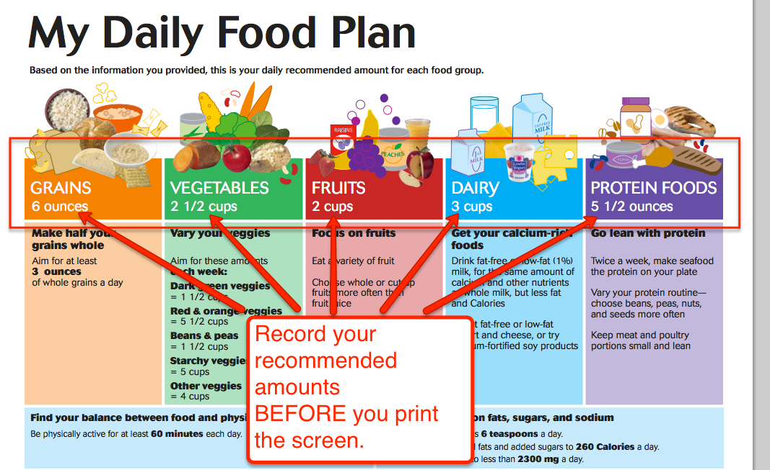

Record your recommended amounts below:

Grains Vegetables Fruits Dairy Protein Foods

_____________ _____________ ___________ ____________ _______________

DO NOT PRINT until you have asked your teacher for permission.

